How to start a First Book Fundraiser on Facebook
- Click Fundraisers in the left menu of your News Feed.
- Click Raise Money (at the bottom of the page).
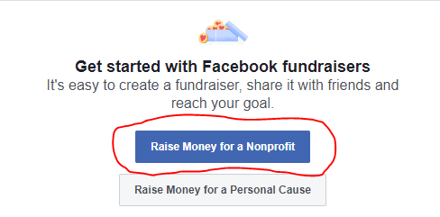
- Search and select First Book as your nonprofit.
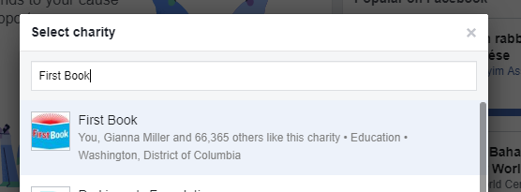
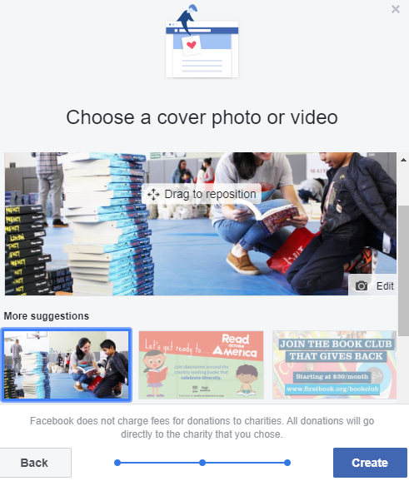
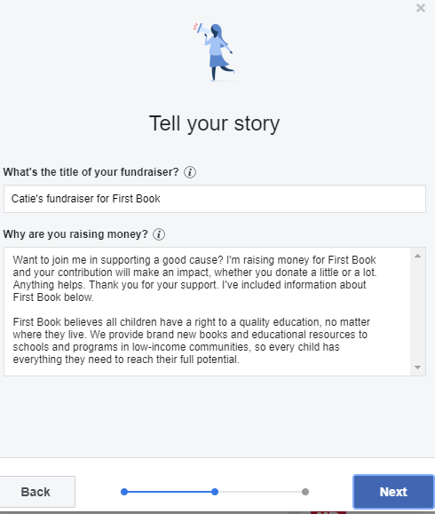
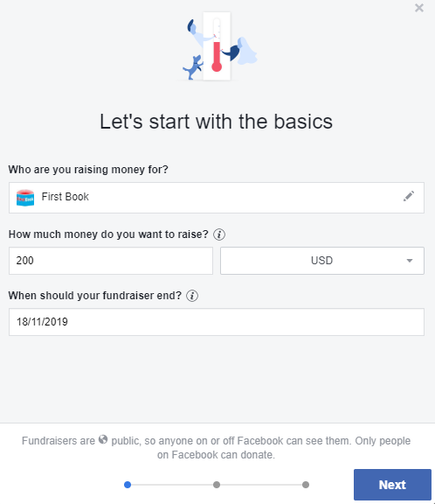
- Select a charitable organization, choose a cover photo and fill in the fundraiser details

- Click Create.

