How to add a donation sticker to your Instagram story

- In Instagram, open the camera and take or upload a photo that you’d like to use to represent First Book.
- Tap the sticker icon.
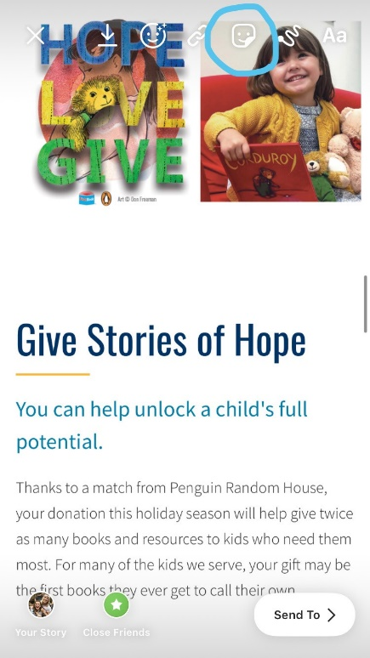

- Select the donation sticker from the tray.
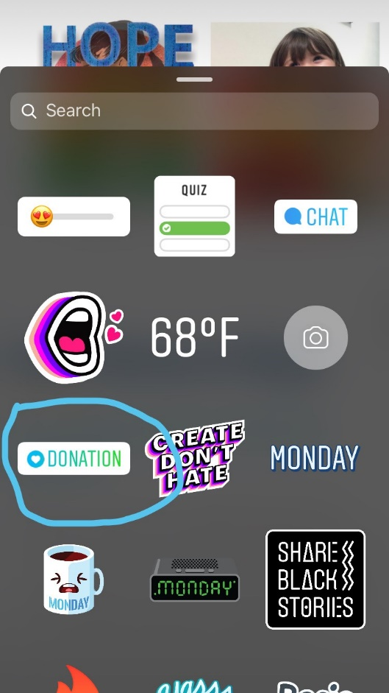
- Select First Book.
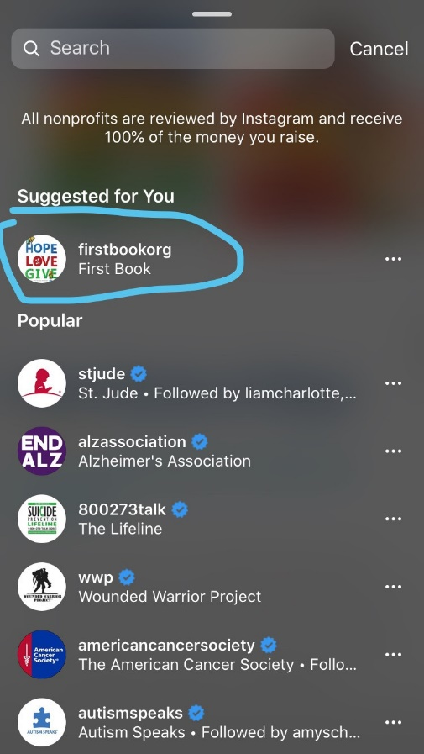

- Tap Send to. Then tap Share next to Your Story.
