How to add a frame to your profile picture
- Go to www.facebook.com/profilepicframes

- Search for a frame by entering hopelovegive.
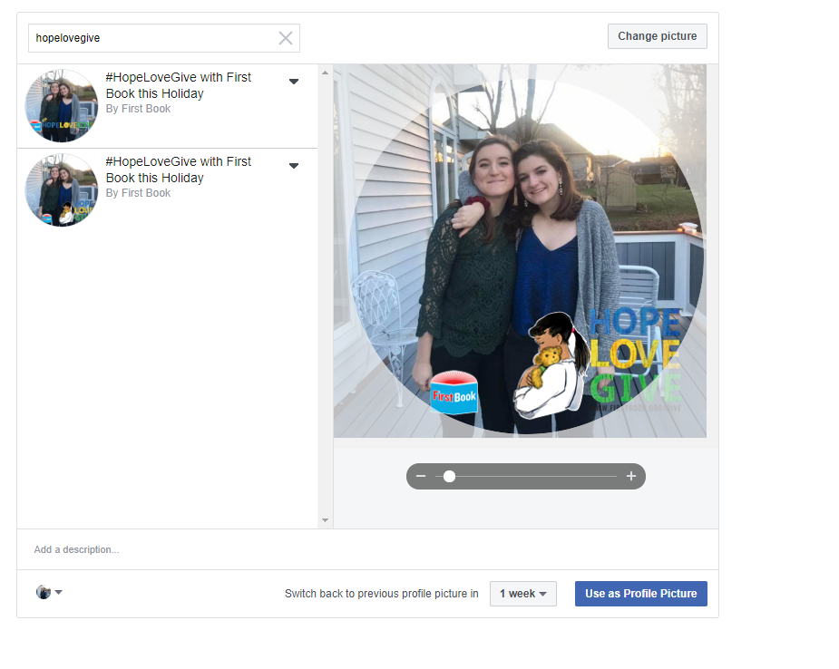

- Choose the frame you want to use from the results.
- Click Use as Profile Picture.

